Pontis Integration in BrT
This document defines the integration between Pontis and BrT systems required for the deployment of Pontis at BrT.
The following drawing summarizes the integration points. The numbers in the drawing are used as reference for the interface description table.
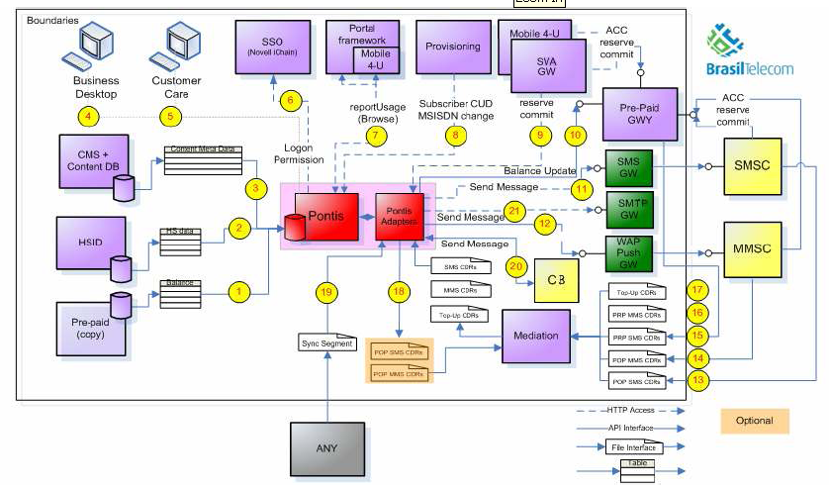
# | Name | Definition | Status | Open Issues
1 | Subscriber pre-paid state | The integration with the subscriber pre-paid state database exposes the subscriber balance and allows Pontis to use the information for segmentation and generating synthetic events (consumption and non-consumption) for balance change.  There is one record per subscriber.  The database will be flattened to a file on a daily basis, accessible to Pontis via FTP. | This interface is required for phase 2. | BrT to send file layout and sample.
2 | HSID | The HSID database includes up-to-date information on the handset used by each subscriber. The information is used for segmentation.  The handset should be matched against a table of features per handset, to allow assigning offers to owners of appropriate handsets.  There is one record per subscriber.  The database will be flattened to a file on a daily basis, accessible to Pontis via FTP. | This interface is required in phase 1.  Pontis to check the ability to load handset features table and use the data in offer definitions. | BrT to send file layout and sample.
3 | Content Management System (CMS) | The CMS integration is part of the integration with the M4U portal. It is required to establish content criteria for offers and locations for placing Pontis generated communications.  The interface loads into Pontis the structure of the portal (categories, types and themes) and the meta-data of the content items.  The portal structure will be externalized as an XML file on a daily basis, accessible to Pontis via FTP. | This interface is required in phase 1.  Further elaboration of this interface will be in a separate document defining the integration with the M4U portal. | M4U to send the XML structure.
4 | Pontis Business Desktop (BDT) | This integration allows the access to the Pontis BDT by the marketing and operations people, without the need to explicitly login to Pontis (using Single Sign On).  The integration is based on access to LDAP. | This interface is required in phase 1.
5 | Customer Support (CSR) | This integration allows access to the Pontis CSR application from the BrT Customer Support environment. A link to the Pontis CSR will be added to the Toolbar. The access will be without the need to explicitly login to Pontis (using Single Sign On).  The integration is based on access to LDAP.  In addition, Pontis related information will be included in the CSR data created by the M4U portal. | This interface is required in phase 1.  The integration with Pontis should be taken into consideration in the integrated CSR view project that is being planned in BrT, possibly with integration via API rather to the application.
6 | iChain | iChain is used as an authentication layer for interactive application. During the meeting it was suggested to use LDAP instead |  | BrT to confirm that the BDT and CSR authentication are to be done using LDAP access and not through iChain,
7 | WAP browse | The WAP browse integration allows the portal to display Pontis generated communications in appropriate portal pages.  BrT has two parts in the portal: the main application framework and the M4U content portal. In the first phase only the M4U portal will be integrated with Pontis.  M4U portal will invoke Pontis browsing API using XML/HTTP protocol. | Interface with the M4U portal is required for phase 1.  Interface with the BrT main portal is required for phase 2.  Further elaboration of this interface will be in a separate document defining the integration with the M4U portal. | Pontis to send API definition and stub for testing.
8 | Subscriber Synchronization / Provisioning | The subscriber synchronization integration loads to Pontis the subscriber attributes, used for recognizing the subscriber and segmentation based on subscriber data.  There is one record per subscriber with all the subscriber data exposed to Pontis.  The information will come from the CRM system or from a Data Warehouse system. | This interface is required for phase 1.  BrT to define where the information will come from and send structure, sample and integration method (extracted file, database access). | In case it is decided to use an online provisioning API, BrT to send API definition and stub for testing.
9 | Advice of Charge | This is the integration between the content purchase in the M4U portal and Pontis. It is used to notify Pontis on any item purchased via the portal and when applicable apply Pontis benefits on content items purchased.  The M4U portal will invoke Pontis API’s (Propose, Reserve, Commit, Cancel) on XML/HTTP as part of the content purchase flow in the portal. | This interface is required for phase 1.  Further elaboration of this interface will be in a separate document defining the integration with the M4U portal. | Pontis to send API definition and stub for testing
10 | Credit Balance | This interface applies Pontis benefits on pre-paid balances, by crediting the applicable balance (general, messaging, data and bonus). Credit is always given in monetary terms (actual Reais) and not minutes or items.  The interface is based on a Pontis call to a CORBA API | This interface is required for phase 2. | BrT to send API definition and stub for testing.
11 | Send SMS | This integration allows Pontis to deliver communications in SMS.  Pontis will send the SMS via an interface to a delivery platform via XML/HTTP, not directly to the SMSC. | This interface is required for phase 1. | BrT to send XML structure for delivery.  BrT to define whether opt-in logic should be applied to triggered SMS (as opposed to mass communications).
12 | Send WAP | This integration allows Pontis to deliver communications in WAP Push.  In the offer definition in the Business Desktop, the link will defined as a full URL  Pontis will send the SMS via an interface to a delivery platform via XML/HTTP, not directly to the SMSC. | This interface is required for phase 1. | BrT to send XML structure for delivery.
13 | Post-Paid SMS CDRs | This interface allows Pontis to receive post paid SMS CDR files. | This interface is required for phase 3.  The details of the interface whre not discussed. | BrT to send CDR file layout and sample.
14 | Post-Paid MMS CDRs | This interface allows Pontis to receive post paid MMS CDR files for processing.  The CDRs are received from the mediation system and passed through Pontis en-route to being rated in the billing system (Geneva). CDRs are taken from a pre-defined location.  The event time used in Pontis for relevance of the CDR to promotions is the event time registered in the CDR, not the processing time.  See 18 (Modified Post-paid for additional details) | This interface is required for phase 1. | BrT to send CDR file structure and sample.
15 | Pre-Paid SMS CDRs | This interface allows Pontis to receive pre paid SMS CDR files. | This interface is required for phase 3.  The details of the interface were not discussed. | BrT to send CDR file layout and sample.
16 | Pre-Paid MMS CDRS | This interface allows Pontis to receive post paid MMS CDR files for processing.  The files are taken from a pre-defined location, separated from post-paid MMS.  MMS CDRs for pre-paid are used for triggering. Benefits for pre-paid are given as balance credits (see integration point 10 – Credit balance). | This interface is required for phase 1. | BrT to send CDR file structure and sample.
17 | Pre-Paid top-ups | The integration with the pre-paid top-ups is used for triggering in offers that produce benefits for top-ups.  The top-up events are sent to Pontis as files, periodically. | This interface is required for phase 2. | BrT to send file layout and sample.
18 | Modified Post-Paid SMS/MMS CDRs | This integration complements integrations 13,14 that defines the incoming stream of post-paid SMS and MMS files.  CDRs not affected by Pontis are placed in the CDR file exactly as they were received. CDRs affected by Pontis include a promotional discount that will be interpreted by the billing system (Geneva).  SMS and MMS files are placed in different locations. | For MMS this interface is required for phase 1.  For SMS this interface is required for phase 3. | BrT to define the location and structure of the promotional discount in the CDR.
19 | Sync Segment | This integration allows ongoing loading into Pontis of segments (lists of subscribers) that can’t be derived from Pontis segmentation.  The interface uses out-of-the-box Pontis functionality, reading files in a defined structure from a pre-defined location and loading them to the system. | This interface is required for phase 1. | Pontis to deliver file structure and sample.
20 | Cells and region | This information is required to send communications based on cell location.  This capability currently does not exist in BrT. | This interface is required for either phase 2 or 3.  Details of interface were not discussed.
21 | Send Email | This integration allows Pontis to deliver communications via e-mail  This capability currently does not exist in BrT. | This interface is required for either phase 2 or 3.  Details of interface were not discussed.

